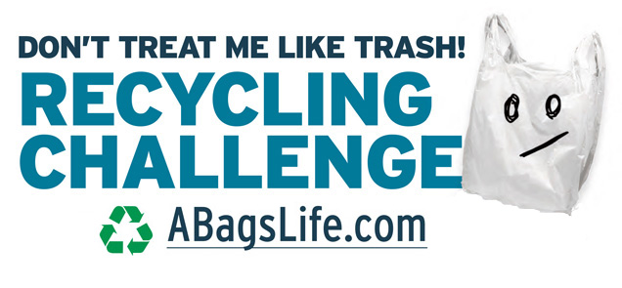
Recycling Plastic Bags in Pasco Schools is Elementary

Pasco County Schools is excited to hold a special contest that teaches elementary students about recycling plastic bags and also rewards prizes.

Plastic bag recycling is not included in our local residential curbside program, so many are discarded as trash and end up in a landfill. To teach the public about plastic bag and film recycling, A Bag’s Life and other environmental partners are bringing this collection contest to our students.

School participation is easy
A Bag’s Life will guide you through the process and Trex, a company that manufactures materials out of recycled plastic bags, will donate a plastic bag/film collection box and poster to each school. A Bag’s Life will provide tip cards for students that explain what other materials can be recycled along with the shopping bags.

A kickoff will be held in September at a host elementary school. From Sept. 5 to Nov. 15 students will bring their bags and wraps to school, where they will be weighed and taken to a local retailer for recycling. Each school will report their bag collections.

The contest ends just before America Recycles Day, a program of Keep America Beautiful, celebrated every year as a nationally recognized day dedicated to promoting and celebrating recycling in the United States.

The elementary school collecting the most bags by weight and the school collecting the most bags per student will each receive a Trex bench, made from recycled plastic bags.

For more details, contact Salinda Strandberg, Recycling Coordinator atsstrandb@pasco.k12.fl.us.

This short video explains a recent contest http://bit.ly/2osaGg8

A Bag’s Life campaign goal is to unite non-profits, students, businesses, community and government organizations to raise awareness and make it easier for more people to reduce, reuse and recycle plastic bags. Visit www.abagslife.com

Sponsored by
Pasco County Schools, Keep Pasco Beautiful, Covanta Pasco, Florida Retail Federation, Florida Department of Environmental Protection, Florida Recycling Partnership

