5th Grade Summer Challenge
Choose as many activities as you can! We will award participants with several levels of prizes whenever you return in the fall!

Zearn  Log into myPascoConnect and click the Zearn Application.Your account has been reset to Grade 4, Modules 5-6 which focuses on fractions and decimals. Rising 5th graders are encouraged to participate in this learning series to ensure they have a solid grasp of these concepts. There are 56 total lessons. See how many you can complete and track it on the sheet provided! | Lexia Core 5  Log into myPascoConnect and click the Core5 Application. How many weeks can you meet your minute goal?!  You should also strive to meet your unit goal! For every five minutes on the app, you should be finishing roughly one unit. | Science Around Me  Look around you. What reminds you of science? Are there plants, animals, light, or weather events? Take a picture of something that you can connect to science and write a caption to describe how the object reminds you of science. Feel free to put everything together on a scrapbook page if you like!
Fitness Challenge  Craft your own summer fitness challenge like 150 pushups, 500,000 steps, or walking 50 miles. Write your goal and how far you got below! | Creative Reading  Using the sheet provided, check off all the unique ways you are able to read! Bonus points will be awarded if you take a Book Taco Test or read any of the 2022-2023 Sunshine State Books. Don’t forget to check our your local library for tons of great reading options! | Gopher on the Go  Take a picture doing something interesting this summer with the attached Georgie Gopher photo. Then, write a paragraph to explain what made this experience so memorable for you!
States & Capitals  Make it your goal to learn the location on a map of all 50 states this summer! We will start the year practicing this, then move to state capitals after you pass your first test! Happy hunting! | T-Shirt Design  Each year, one lucky 5th grader draws a design that is chosen for our 5th grade shirt! Start this challenge now! Please see the attached guidelines for all the specifics on the 2022-2023 contest! | Multiplication Facts  Practice reciting your 6, 7, 8, and 9 multiplication facts as much as possible! We have attached some notecards so that you can write the trickiest facts on these as flash cards for extra practice.

2022-2023 T-Shirt Design Contest

We are already looking forward to ordering fifth grade spirit shirts for our students again this year! Each student has the opportunity to submit a t-shirt design that will encompass the theme of preparing to be “Life-Ready” which could include careers, institutions for further education, military, etc. Teachers will choose the top designs, then students will vote for their favorite choice. We will wear these shirts throughout the school year for spirit days, field trips, fifth grade events, and so on.

Please adhere to the following guidelines while designing:

- Design using two colors only (black is considered a color.)
- Please do not use college logos or other copyrighted images.
- Designs may be drawn by hand or computer-designed, but MUST be an original creation.
- Drawings should be related to the “Life-Ready” theme.
- Please include our school mascot- the gopher tortoise.

Stay tuned for more information about purchasing Fifth Grade T-Shirts after the start of the school year. All designs are due by August 17, 2022. We look forward to seeing your creative and innovative designs!

Sincerely,

Fifth Grade Teachers

United States Map Practice

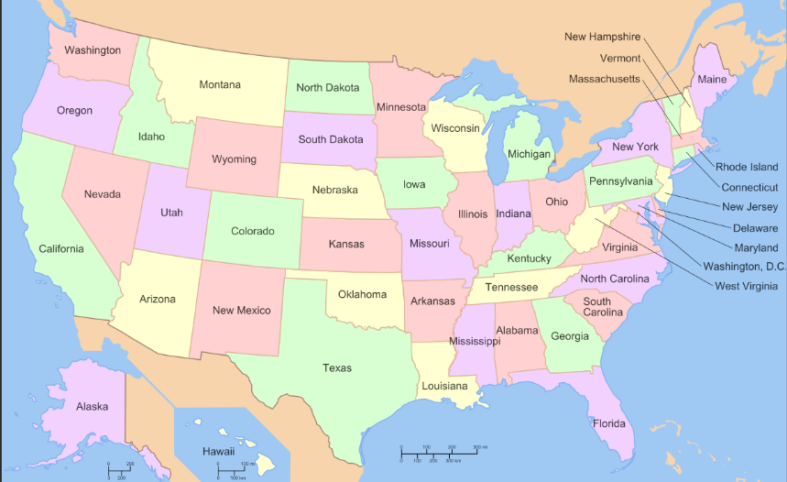

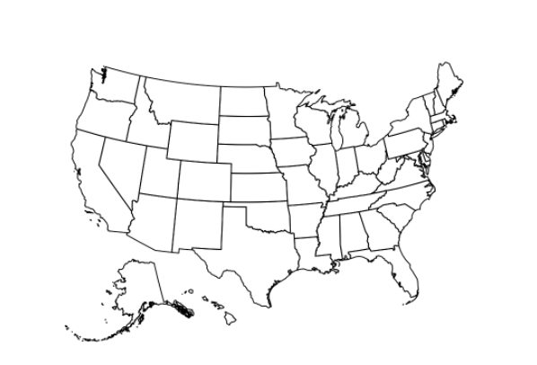

Georgie Gopher on the Go!

The Zearn Challenge

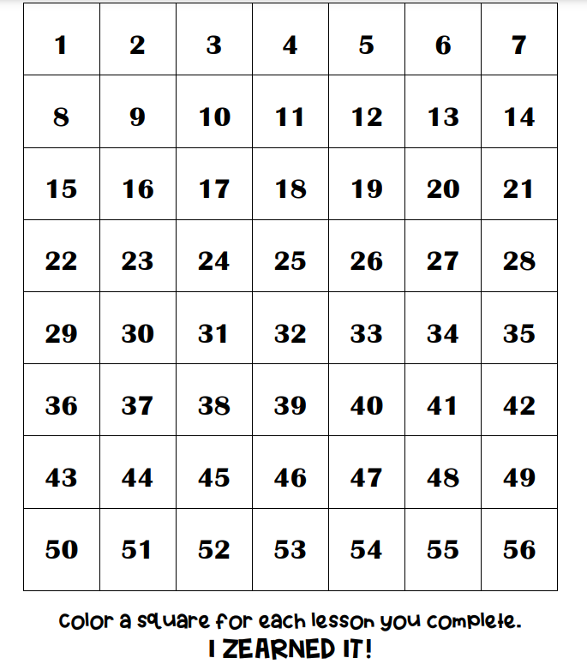

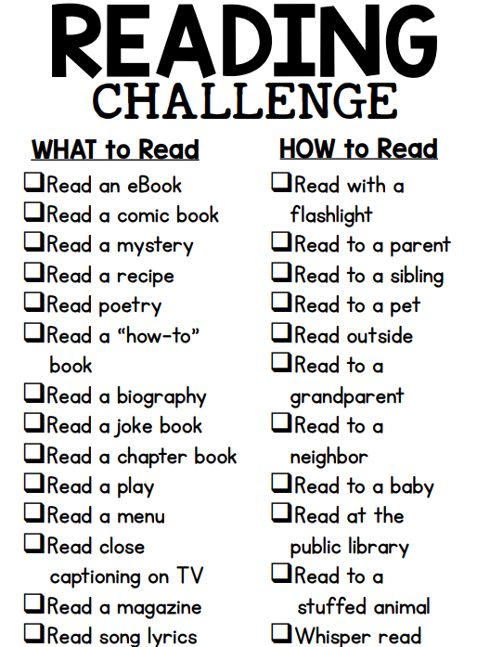

Bonus 1: Take a Book Taco Test
Bonus 2: Read a Sunshine State Book

