Before Kindergarten Starts
Please work with your child on:
Check | Idea | Examples
 | Understanding personal information (first/last name, parents names, transportation (bus number), siblings, student number | Asking questions and talking about the answers to these questions is important for child entering Kindergarten because their teacher does not know them yet and in order to help them better knowing this information about themselves is key.  Questions:  What is your name?  What is your last name?  Who are your parents?  What is your bus number?  Do you have brothers or sisters? What are their names?  Name tag option  Name Tag option  (These are just options NOT REQUIRED)  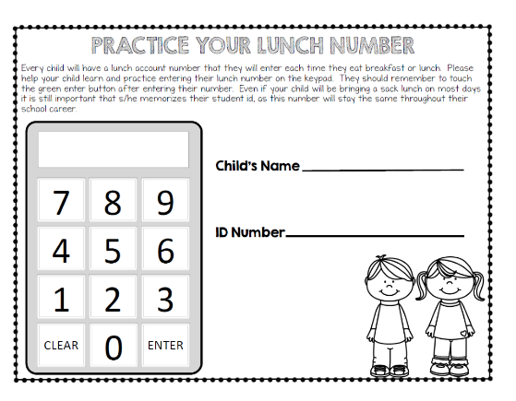
 | Write their first name or attempt to with good pencil grip | Many prek's will teach your child to write their name using capital letters. This is because it is easier to form the straight lines. The expectation for Kindergarten is write lowercase within their name. The sooner you switch over the habit of writing in lowercase the better writers they will become overall. You can use highlighter or dots and have them trace it.  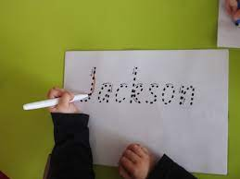  After they have mastered tracing move on to copying  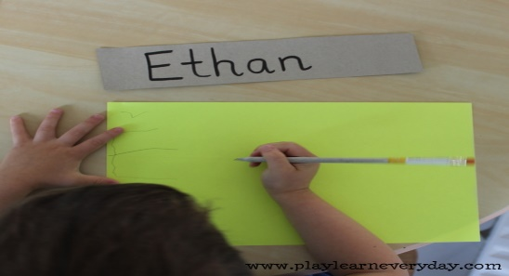  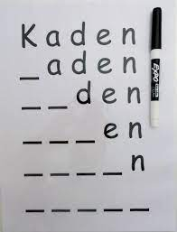  Pencil Grip option  Article about teaching to write their name and pencil grip  Correct Tripod Pencil Grip for Writing. How to Hold a Pencil Correctly For Foundation & Kindergarten
 | Tell an adult if something is wrong and ask for help when needed | Using simple phrases can help your child when they are struggling and need assistance. We don't want your child to sit in silence and not know they need help with something. You know your child best so teaching them simple or complex phrases can help them when they need assistance. If you child is shy just having them say, help, bathroom, water, etc.
 | Take care of basic needs on own (bathroom, tissues, lunch)
 | Read often (You can read to them, they pretend to read with a picture walk) | Reading to your child - Use a fun "reader voice." Point to one word at a time  Discuss parts of book (cover, spine, title, author/illustrator, characters, setting)  Use pictures as clues to what is happening in the story. Allow child to make predictions, "What do you think will happen? Why?"  Independence: Allow story telling when looking at books independently – Practice book handling, reading from left to right, turning pages carefully. Putting book away with spine out or cover facing forward.
 | Use scissors and glue correctly | *thumb in small hole, thumb on top, fingers in bigger hole on bottom  *"nibble nibble" movement when following a line of any shape  *use other hand to turn and control paper  *YouTube for how-to's, how to correct  Scissor Skills | SCHOOL READINESS | How to teach your child to use scissors correctly  Glue stick practice and reminders:  Only twist until you see a bit! "dot, dot, not a lot"  - Push gently on back of piece you want to glue, then stick on  - Careful putting cap on, not to get glue on it (prevent cap from getting stuck)  - Click cap all the way down so glue does not dry out  https://www.youtube.com/watch?v=HSxYKwmrAes
 | Follow two step directions | Have fun with it! Play just like Simon Says:  - Sit down on the floor and close your eyes.  - Touch your head and turn in a circle.  - Stand up and pretend to be frozen.  - Bounce the ball and say your name.  - Do a jumping jack and then sit on the chair.  - Hop on one foot and smile
 | Dress themselves (shoes, jackets, pants buttons, backpacks) | The Best way to master these skills is to PRACTICE, PRACTICE, PRACTICE!  Shoes:  EASIEST way how to teach a child to tie shoes!!  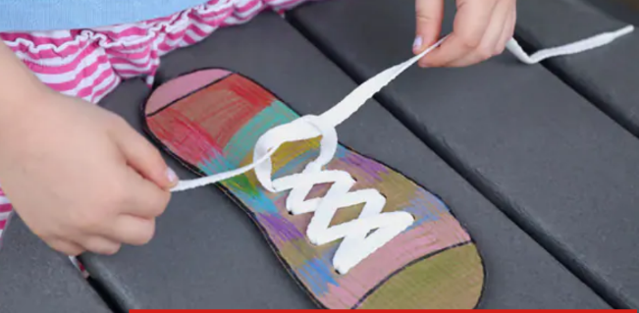  Jackets:  Teach Kids to Put On Their Own Coat (Tips from a Preschool Teacher)  Backpacks:  How to for kids | Give it a go | How to pack your bag | Independent Kids| Pevan and Sarah
 | Count to 10 and be able to count groups of objects to 10 | - Practice counting and writing numbers from 1-10.  - Have them point to each object as they count.  - Have them practice counting on starting from a different number. Ex. 3-10 or from 6-10.  Try these two fun games to practice counting and writing numbers using common household items such as cotton balls, cupcake liners and playdough.  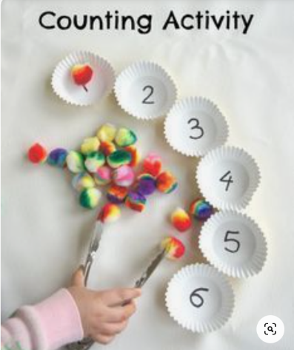  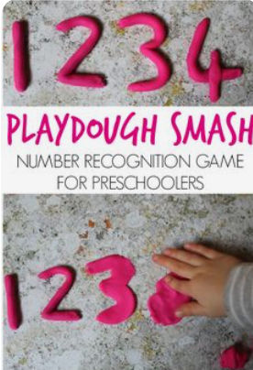
 | Take turns and share | Practice sharing by sharing snack or toys with others in your family or with friends.  Go to a park and practice taking turns with others.  Practice words/phrases such as: "I'd like a turn please," or "you can have a turn when I am finished." Also, "can you please pass me the __________," and "please or thank you."  Have your child use feeling words: "I am feeling _______ right now because _____...  Read a story on sharing:  The Duck Who Didn't Want To Share | A Story About Sharing (The Duck Who didn't want to share- On YouTube.)
 | Recognize and name upper and lowercase letters (not in ABC order) | - The Letter Sounds Song  - Upper and lowercase letter matching activities  - Flash speed - "What's this letter's name? What sound does it make? Ex: m = /m/ "mmmmm," be careful not to say /muh/ How to say the M sound by Peachie Speechie  - Specific letter songs (one letter at a time) google "letter __ song" Jack Hartmann, ABCmouse, storybots  - Practice making letters or your name using playdough, shaving cream or whipped cream. You could also give them a stick and have them draw letters/name in a sand box or dirt if you have it.

